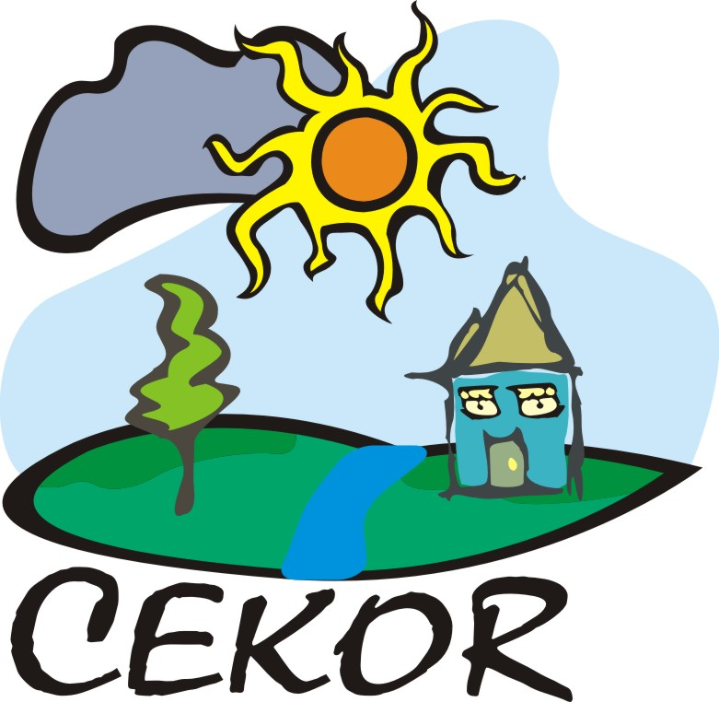

8.2.2010
Belgrade,
New blog on Gazela resettlement provides evidence of the challenges ahead

As a result of plans to renovate the Gazela Bridge over the River Sava in Belgrade, on 31 August 2009, the predominantly Roma inhabitants of the informal Gazela settlement were physically resettled. In total, 114 families considered to be from Belgrade were moved to temporary container accommodation in five locations at the outer edges of Belgrade, and 61 families were transported to their towns of origin in southern Serbia.

While the physical conditions have improved for families resettled in Belgrade area - they are now living in container accommodation rather than shacks cobbled together from whatever they could find - large question marks remain over the plans for long-term accommodation and employment and the fate of those transported to southern Serbia.

Our blog at http://outofsight.tv/ aims to document how the resettled families are getting on in their new locations, what still needs to be improved in this resettlement project, and what should be done differently in future projects.

CEE Bankwatch Network and Center for Ecology and Sustainable Development

---------------------------------------------------------------------------------------------------------------
Novi blog o raseljavanju sa Gazele daje uvid u izazove koji predstoje

Kao rezultat planova da se rekonstruiše most Gazela preko reke Save u Beogradu, 31 avgusta 2009. stanovnici uglavnom romske populacije ilegalnog nehigijenskog naselja Gazela su i fizički preseljeni. Ukupno, 114 porodica koje se smatra da su iz Beograda je premešteno u privremene stambene jedinice- kontejnere na pet lokacija na obodima Beograda, a 61 porodica je transportovana u gradove južne Srbije odakle potiču.

I dok su se za porodice raseljene u reonu Beograda uslovi življenja poboljšali – oni sada žive u kontejnerskom smeštaju nasuprot dosadašnjim kolibama sklepanih od bilo čega što se moglo naći – veliki znak pitanja ostaje prema planovima za trajni smeštaj i zapošljavanju kao i za sudbinu onih koji su prebačeni na jug Srbije.

Naš blog na http://outofsight.tv/ ima za cilj da dokumentuje kako se raseljene porodice snalaze na novim lokacijama, šta još treba da se poboljša u ovom projektu raseljavanja, i šta bi se ubuduće trebalo drugačije uraditi kod sličnih projekata.

CEE Bankwatch Network i Centar za ekologiju i održivi razvoj

